The EU’s ETS and free emissions allowances – pitting a subsidised, evolved industry against greenhorns

Sangeeta Godbole

The European Union’s Emissions Trading System (ETS) is the principle and the architecture based on which the EU will implement its Carbon Border Adjustment Mechanism (CBAM). Establishing an ETS, which is one of the two main types of explicit carbon pricing mechanism (the other being carbon-based fees or taxes), has taken the EU over two decades and required a large outlay of financial resources and a consistent capacity-building and monitoring exercise.

The ETS has taken shape gradually, beginning with free allowances for emissions and a gradual tightening of available emissions thresholds. The common objective of reducing carbon emissions through setting emissions thresholds and emissions caps binds the ETS and the CBAM. The ETS sets the total number of allowances issued – the ‘cap’ – on the greenhouse gas emissions from activities within its scope and allows trading of allowances. It is therefore called the ‘cap and trade system’. The emissions caps were reduced gradually from 2.08 billion allowances in 2013 to 1.57 billion allowances in 2021.

The current ETS covers electricity and heat generation, energy-intensive industry sectors, including oil refineries, steel works, and production of iron, aluminium, metals, cement, lime, glass, ceramics, pulp, paper, cardboard, acids and bulk organic chemicals, and aviation within the European Economic Area. However, the CBAM currently covers only five sectors that are covered by the ETS (iron and steel, aluminium, cement, fertilisers, and electricity), as well as the hydrogen sector, which is not covered by the ETS.

The ETS evolved over two decades. A Green Paper published by the European Commission in March 2000 set out the rationale for an emissions trading system and its benefits for tackling climate change in view of the EU’s commitments under the Kyoto Protocol. A directive was adopted in 2003 and national allocation plans were set, with the year 2005 witnessing the launch of the EU’s ETS. The system has since undergone several amendments and modifications.

In the first phase – a period of three years between 2005–2007 – all allowances were fixed by the ETS at the national level and were distributed free. Only power generators and energy-intensive industries were required to report emissions. This first phase contributed to setting up an acceptable infrastructure and system, allowing industry to absorb the idea of a price on emissions and to trade in free emissions allowances.

In the second, five-year phase (2008–2012), during which Norway, Iceland and Liechtenstein joined the ETS, the free allowances continued to range up to 90% of allowed emissions. Essentially it was an extension of trade in free emissions. This created a large surplus of free allowances, leading to very low carbon prices.

In the third, eight-year phase (2013–2020), auctioning of allowances (as opposed to free allowances) became the main feature. The sectoral coverage widened significantly. However, allowances were still given for free where the EU perceived carbon leakage; this is considered by experts to be a substantial subsidy for EU industry. One estimate puts the subsidy received by EU heavy industry so far, in terms of free allowances, at €238 billion, with an additional €400 billion to be disbursed till 2030. That gives a massive sum of over €600 billion in free-allowances subsidy!

As noted in a recent special report by the EU Court of Auditors, all emissions allowances were free until 2012, which enabled EU industry to make substantial profits by trading in these free allowances. Windfall profits were made by corporations in certain sectors at the cost of EU consumers due to the free emission allowances allocation under the ETS. The authors of the report estimate that additional profits in the range of €30–50 billion may have accrued in the 15 most carbon-intensive sectors in the EU between 2008–2019.

The fourth phase of the ETS (2021–2030) promises to be more stringent than the earlier phases, with emissions allowances progressively declining by an annual linear reduction of 2.2% in phase IV, as compared with 1.74% annual linear reduction in phase III. Free allowances will be more targeted and dependent on actual production. However, sectors with the highest carbon leakage will continue to receive 100% allowances for free.

The European Commission periodically issues a list of sectors and sub-sectors that it assesses as being prone to greater carbon leakage. The current list, applicable until 2030, includes several sectors such as mining of hard coal, extraction of crude petroleum, mining of iron ores, mining of other non-ferrous metal ores and minerals, chemical and fertiliser. The sectors listed are provided 100% free allowances to cover their emissions. These allowances are deemed to be transitional but have continued to be allocated since 2003.

In fact, in certain CBAM sectors like production of iron and steel, and primary and secondary aluminium production, free emissions allowances largely continue to be much higher than verified emissions, as can be seen in data provided by the EU in Figures 1 and 2. Does that make a mockery of the whole emissions reduction campaign that the EU has engulfed the entire world in?

Figure 1
Allowances and emissions for production of pig iron and steel under the EU ETS
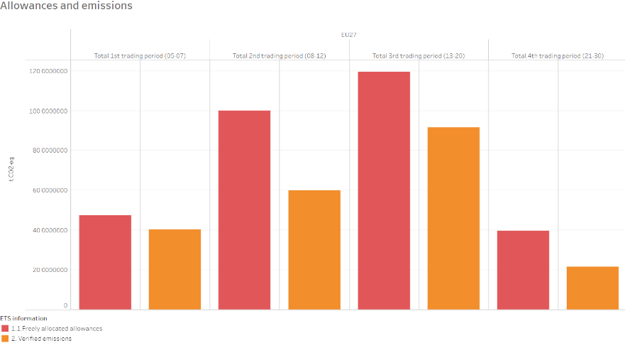
Source: https://www.eea.europa.eu/data-and-maps/dashboards/emissions-trading-viewer-1, retrieved on 26 February 2024

Figure 2
Allowances and emissions for production of primary and secondary aluminium under the EU ETS
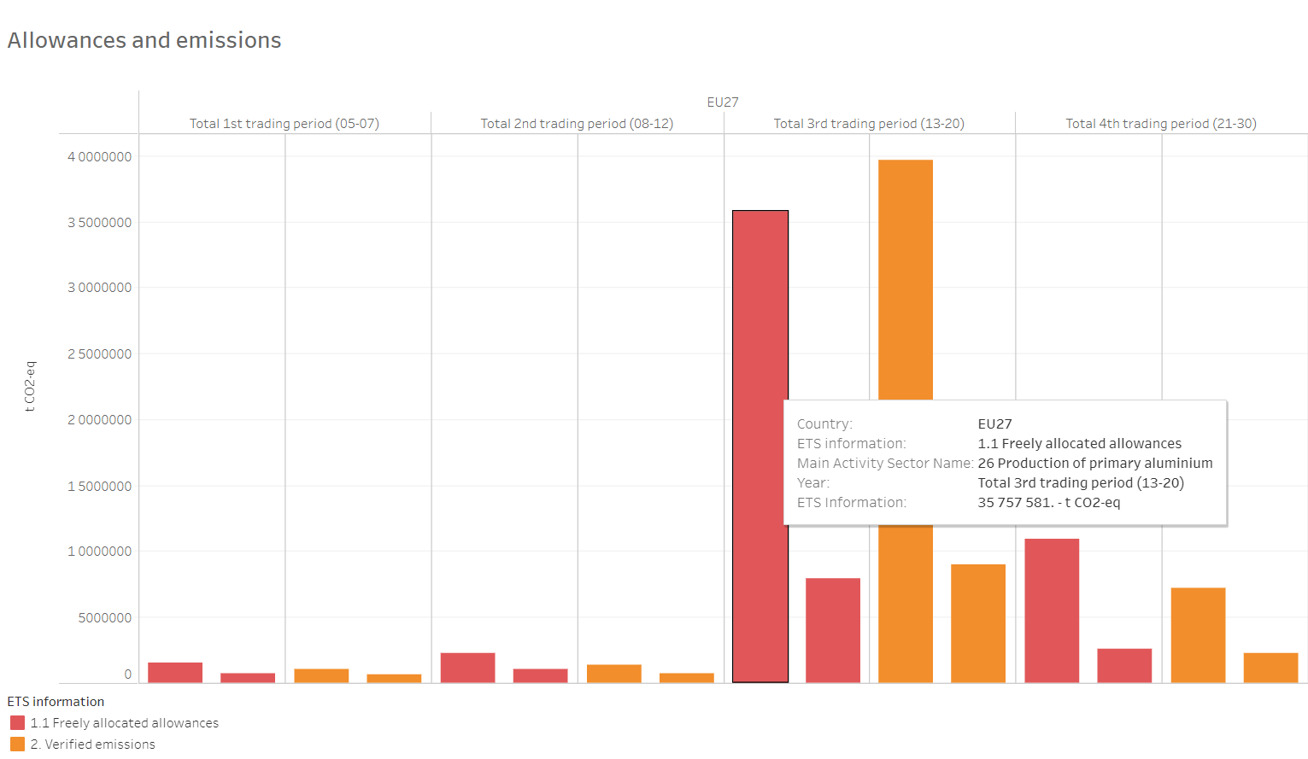
Source: https://www.eea.europa.eu/data-and-maps/dashboards/emissions-trading-viewer-1, retrieved on 26 February 2024

In addition to free allowances to industries perceived to be at risk of carbon leakage, the EU has also authorised state aid to installations that have high electricity costs and face significant international competition. State aid in the order of billions of euros will continue to support these industries until 2030. Funds have been allocated to all EU member states to be spent on supporting industry till 2030. Germany (€27.5 billion), Spain (€2.9 billion) and Italy (€1.49 billion) are some of the indicative allocations.

Implementation/administrative costs

A transparent, efficient and consistent monitoring, reporting and verification (MRV) mechanism is the sine qua non of a stable and effective ETS. For the ETS to be trusted and to retain its integrity, it is necessary that one ton of carbon emissions measured, reported or verified in one country must be exactly the same as one ton measured, reported or verified in any other country. Given the number of actors involved in this process – competent authority/ies of each member state, operators, verifiers and national accreditation bodies – stringent compliance is necessary from each actor in each stage of the MRV process. The MRV process and the required rigour in implementation entail compliance costs not only for industry installations but also for the competent authorities of member states, verifiers and national accreditation bodies.

Establishing and implementing an MRV system would be the most fundamental step for any country that wants to export CBAM-covered products to the EU. Developing countries exporting CBAM products will have to per force design, establish and implement MRV systems, or face high default emission values attributed to their exports. These will make their exports uncompetitive irrespective of their actual emissions. Without an MRV system in place, individual installations will have to establish their own monitoring and reporting mechanisms, which would imply very high costs apart from uncertainty surrounding the decisions that EU verifiers may take on the emissions measurement reports.

The EU’s Directorate-General for Climate Action has published a study on costs of compliance with the ETS in the 18-month cycle ending in 2014. According to this study, the average cost per member state for the 2014 compliance cycle (as an indicative compliance cycle under phase III of the ETS) was €51,800 and the average cost per member state per installation was €2,250. The average cost per installation for the 2014 compliance cycle was €59,200. These are 2014 figures and still pose a substantial cost if converted to local currencies, particularly in developing-country contexts.

The survey also observed that ETS MRV costs were proportionately higher for smaller emitters. Quality control costs took up the highest share of the monitoring costs incurred by the emitters. Small operators and simple emitters found the MRV process cumbersome and challenging to follow. Reporting requirements were perceived as high and complex by these installations.

Most EU member states provided trainings, consultations and templates to operators to support proper adoption of the ETS MRV. An electronic reporting system that was present in certain member states reduced the costs of compliance significantly.

The measures that countries had to take to ensure compliance included spot checks and inspection of implementation and compliance by installation, industry meetings, verifier consultations and prohibiting sale of emissions allowances if irregularities were noticed.

A study of transaction costs for the ETS in Ireland confirmed the above findings particularly for smaller emitters. While larger installations incurred high initial costs, ongoing costs for small and medium installations were burdensome.

A relatively recent study commissioned by the Dutch emissions authority reveals that costs incurred by firms for the current phase IV of the ETS will go up as the ETS threshold caps are lowered and MRV requirements become more stringent. Additional data collection and production level changes will increase the costs of administering the ETS. Similar costs will have to be borne by exporting-country installations after the CBAM is in place.

Further, if the same installation manufactured different products, the data collection and MRV exercises would become proportionately more complex and impose additional costs on the administrators.

A subsidised, emissions-evolved industry

EU industry has incrementally developed capacities for reporting emissions, understanding and integrating emissions caps into its business processes, adopting the best available technology (BAT) and trading allowances on the market. The extended adaptation period of almost two decades and large resources by way of free allowances have created an emissions-evolved industry in the EU.

In contrast, developing-country exports to the EU will now face the same ETS, emissions caps and prices without the experience or benefits of an extended period of adaptation, technology or resources.

The CBAM is intended to create a level playing field between EU producers subject to the ETS and non-EU producers not subject to the ETS. However, in reality, it instead exacerbates inequalities between industrial actors coming from disparate and unequal situations. It pits the EU’s emissions-evolved, free allowances–rich industry against developing-country industry which has zero exposure to carbon emissions reductions and trading.

These developing countries will have to set up an MRV mechanism for emissions. Implementation of such mechanisms will require financial and administrative capacities which many of these countries do not possess. Should these countries’ industry not also be entitled to free allowances for the first few years, just as EU industry will receive over €400 billion in free allowances till 2030?

Such a large scale of free allowances raises questions as to whether the CBAM really is a carbon emissions reduction measure. Why would the EU continue to subsidise the emissions of its industry if it were focused on emissions reduction? By heavily subsidising its own emissions, while taxing and penalising those of its imports, the EU has embarked on an ambitious protectionist path under the guise of climate action.

Sangeeta Godbole is a former officer with the Indian Revenue Service (IRS). Her research interests lie in the trade and environment intersection.

